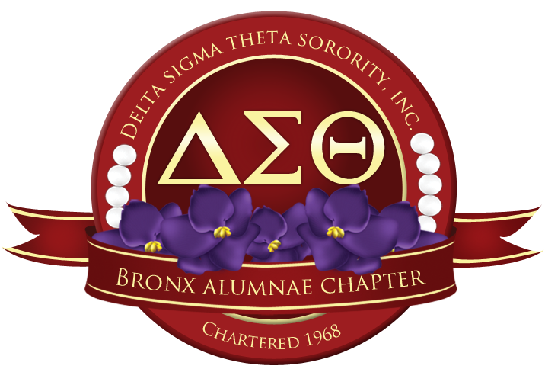

2022 SCHOLARSHIP APPLICATION

Description

An $8,000 scholarship dispersed in payments of $1000.00 per semester, to a promising high school senior whom:

A. Resides in the Bronx and maintains a minimum overall academic B average.

B. Will enter a four-year college as a full-time student in Fall 2022.

The scholarship is for a maximum of four years if student maintains a 3.0 grade point average based on a 4.0 scale each semester.

In addition, there are also several 1-time grants in various amounts that are available to high school seniors as well!

To Apply For Scholarship

Complete this form and submit the following information:

- Submit a two-page, 12pt font-Times New Roman, double spaced typed essay, min 750 words-1000 words max, titled: “DST Scholarship Essay”. Be sure to include your name on the essay in the upper right hand corner. Select ONE of the essay prompts below:

- Describe an accomplishment or challenge you have experienced. How has that accomplishment or challenge impacted your life?

- Since March 2020, we have lived in a pandemic. As you prepare to transition to college, how has the pandemic changed your views on the world?

- Describe a problem you have solved or a problem that you would like to solve within your community. Explain its’ significance to you and what steps you took or could you take to identify a solution.

- Provide two (2) letters of recommendation – one must be from a teacher/ guidance counselor and one from a community service supervisor. This person may not be a relative.

Recommendation letter MUST:
- Be on official school or organization letterhead.

- State the recommender’s name, relationship to the applicant, and length of time he /she has known the applicant.

- Be addressed to Delta Sigma Theta Sorority, Inc., Bronx Alumnae Chapter Scholarship Committee.

- Speak to the applicant’s character, education, service, level of commitment, and any other pertinent information the committee should consider.

- Be given to the student in a sealed envelope with signature across the seal for submission with the completed application packet.

Note: information contained in the letters is confidential and will be treated as such.

- An official high school transcript

- A copy of your ACT or SAT scores if applicable for the 2021-2022 school year.

RETURN APPLICATION TO:
Delta Sigma Theta Sorority, Inc.
Bronx Alumnae Chapter
P.O. Box 102
Bronx, New York 10467
ATTENTION: Ms. Knight, Scholarship Chair

DEADLINE DATE: Application must be postmarked no later than:
Saturday, February 26, 2022.

ATTN COUNSELORS AND STUDENTS:
ALL APPLICATIONS ARE TO BE MAILED OUT.
NO ELECTRONIC SUBMISSIONS OF APPLICATIONS ARE ACCEPTED. DO NOT EMAIL YOUR APPLICATION MATERIALS OR LETTERS OF RECOMMENDATION.

Prior to mailing of the application, please use the checklist on pages 7-8 to ensure you have included all the necessary materials for your application packet prior to mailing!

STUDENT DATA
(Complete fully – please type or print clearly)

Personal Data

Name: Last_________________________ First_____________________ M.I. ______

Address: ____________________________________________ Apt #:____________

City:________________________State:______________________Zip:_____________

Date of Birth:___________________Place of Birth:___________________

Phone Number: ____________________________Email: _________________________

Academic Data

High School: ________________________________Telephone #:__________________

Name of Name of Principal:_________________________Guidance Counselor:______________________

Cumulative Grade Point Average: ________ACT Score:_______SAT Score:__________

Organizational involvement honors, and Special Interest (if applicable) :

Awards | Membership | Honors

Community Service Activities

Name of Activity | Dates | Frequency | Roles and Responsibilities

Have you participated in any Bronx Alumnae Chapter Youth Program?

Yes_____ No___ If yes, _____________________________ (Name of program)
Potential College/ University

List the names of colleges and universities you are applying to:

School Name
School Location
Application Status check all that applies | O Pending O Accepted | O Pending O Accepted | O Pending O Accepted
Annual Tuition
Room and Board
Total Annual Cost

What area(s) of study do you plan to pursue in college? __________________________

Do you plan to apply for federal financial aid? _________ Yes __________No

Where do you plan to live? ___On-campus ___Off-campus ___Commute ___Undecided

Other Scholarship/ Financial Awards

List any other scholarships or financial awards applied for or received.

Grant, Awards, Scholarship | Term of Award  (one time, 1 year, 4 years) | Total amount of reward

Parent/Guardian Information

Name | Relationship | Occupation

Number of dependents in household____ Number of dependents currently in college____

Declaration

I hereby declare that all the above statements are true and correct to the best of my knowledge. I have concluded with this application with the necessary official transcript, and letters of recommendation are in sealed envelopes. I am willing to appear in person for an interview via zoom or live. Any incomplete section of the application or any missing documents will void this application.

If awarded the Bronx Alumnae Chapter Scholarship, I understand that I must be entering a four-year college as a matriculating student in September 2022, or I will forfeit the entire scholarship.

I agree to accept the decision of the Scholarship Committee of Delta Sigma Theta Sorority, Inc., Bronx Alumnae Chapter.

Signature of Student__________________________________Date_________________

RETURN APPLICATION TO:
Delta Sigma Theta Sorority, Inc.
Bronx Alumnae Chapter
P.O. Box 102
Bronx, New York 10467
ATTENTION: Ms. Knight, Scholarship Chair

DEADLINE DATE: Application must be postmarked no later than:
Saturday, February 26, 2022.

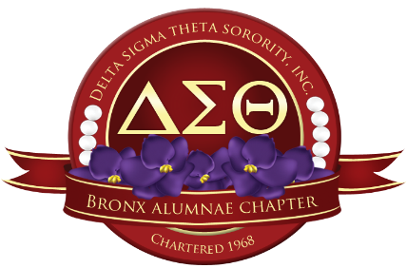

*Please give this letter to your recommender*

November 2021

To Whom It May Concern:

The prospective applicant ________________________________ has selected you to write a recommendation letter for them.

They are applying for the Bronx Alumnae Chapter of Delta Sigma Theta Sorority Inc. 2022 Scholarship. Here are the guidelines in providing a letter of recommendation for the aforementioned applicant:

Recommendation letter MUST:

- Be on official school or organization letterhead.

- State the recommender’s name, relationship to the applicant, and length of time he /she has known the applicant.

- Be addressed to Delta Sigma Theta Sorority, Inc., Bronx Alumnae Chapter Scholarship Committee-P.O. Box 102, Bronx, NY 10467.
- Speak to the applicant’s character, education, service, level of commitment, and any other pertinent information the committee should consider.

- Be given to the student in a sealed envelope with your signature across the seal for submission with the completed application packet.

DEADLINE DATE: Application must be postmarked no later than Saturday, February 26, 2022.

ATTN COUNSELORS AND STUDENTS:
ALL APPLICATIONS ARE TO BE MAILED OUT.
NO ELECTRONIC SUBMISSIONS OF APPLICATIONS ARE ACCEPTED. DO NOT EMAIL YOUR APPLICATION MATERIALS OR LETTERS OF RECOMMENDATION

2022 Scholarship Application Checklist!

Before mailing your application in, did you….

- Print and complete the form with all the necessary information?

- Submit a two-page, 12pt font-Times New Roman, double spaced typed essay, min 750 words-1000 words max or less, titled: “DST Scholarship Essay”. Be sure to include your name on the essay in the upper right hand corner. Select ONE of the essay prompts below:

- Include your name on the essay and chosen one of the essay prompts below:
- Describe an accomplishment or challenge you have experienced. How has that accomplishment or challenge impacted your life?

- Since March 2020, we have lived in a pandemic. As you prepare to transition to college, how has the pandemic changed your views on the world?

- Describe a problem you have solved or a problem that you would like to solve within your community. Explain its’ significance to you and what steps you took or could you take to identify a solution.

- Provide two (2) confidential letters of recommendation This person may NOT be a relative.
- One must be from a teacher/ guidance counselor
- One from a community service supervisor with the necessary criteria provided within the recommendation letter.
Recommendation letter MUST:
- Be on official school or organization letterhead
- State the recommender’s name, relationship to the applicant, and length of time he /she has known the applicant
- Be addressed to Delta Sigma Theta Sorority, Inc., Bronx Alumnae Chapter Scholarship Committee.
- Speak to the applicant’s character, education, service, level of commitment, and any other pertinent information the committee should consider
- Be given to the student in a sealed envelope with signature across the seal for submission with the completed application packet.
- An official high school transcript
- A copy of your ACT or SAT scores if applicable for the 2021-2022 school year.

Once you have checked off all the boxes and made sure to have all the necessary documents, you are ready to mail your application packet to:

Bronx Alumnae Chapter
Delta Sigma Theta Sorority Inc.
P.O. Box 102
Bronx, NY 10467
Attn: Ms. Knight, Chair of Scholarship
All Materials must be postmarked by Saturday, February 26, 2022!

